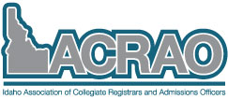

Idaho Association of Collegiate Registrars and Admissions Officers Board Meeting

August 28th, 2017
4:00 PM
Google+ Hangouts

Board Members
Dana Gaudet, Idaho State University, OSBE Representative | Samantha Grapes, College of Western Idaho, Registrar Chair
Corinne Mccullough, Idaho State University, Technology Chair | Katie Price, College of Western Idaho, President
Ashley Larson, Idaho State University, Admissions Chair | Dan Guthrie, College of Southern Idaho, Past-President
Aubi Crabtree, Idaho State University, Secretary/Treasurer | Justin Horn, College of Western Idaho, Technology Specialist
Greg Franz, College of Idaho, President-Elect

Agenda Items

- Counselor Days updates
  - PowerPoint- important updates (Ashley)
  - Teresa B from NIC wants to know about expected #s and boxes
  - September 18th ISU – Eastern Idaho
  - September 19th CSI- Magic Valley
  - September 20th BSU- Treasure Valley
  - September 21st U of I – North Idaho South
  - September 22nd NIC- North Idaho North
  - Discuss Apply Idaho process with counselors?
- Website
  - Review and feedback (Dana Gaudet)
  - Apply Idaho videos- add to website?
  - College banners on home page slideshow- update?
    - 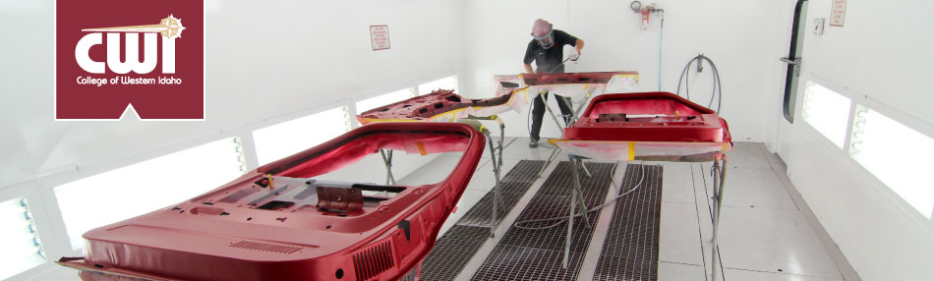
    - http://iacrao.weebly.com/
- College Application Week updates
  - November 6-10th
- Higher Education Tour
  - Contact cards-do we want to do this again?
  - Video updates- Aubi update on invoices
  - Book updates – Corinne has updates
    - IACRAO website ad
  - Tour updates
    - Student survey (Dana Gaudet)
    - Tribal schools want to participate more this year/Patty Sanchez State Dept. of Ed.
- Updating counselor contact lists for website
  - How do we want to do this? Split up by region?
    - https://www.sde.idaho.gov/ed-directory.html
- Registrar survey results (Sam updates)
- Monthly newsletter for admissions and registrar information (refer to Dan’s email)
- IACRAO Conference 2018
  - Schedule date/place for 2018?
    - Thoughts on having it at CWI?
    - Kellen Willis suggested doing it as a joint conference with PNACAC again this year and having it at NIC, PNACAC will be at Gonzaga University. Thoughts?
- New Business

